Waterproof large capacity golf culb set
1.Super game improvement design focuses on generating more distance for beginner golfers
2.Large 460cc Titanium matrix driver uses hot face and low center of gravity to launch the ball off the Tee
3.Large sweet spot irons feature perimeter weighting for improved performance on off center hits
4.Alignment putter with soft Paddle grip improves aim and distance for all golfers
5.Lightweight ergonomic bag features self activating stand and numerous pockets
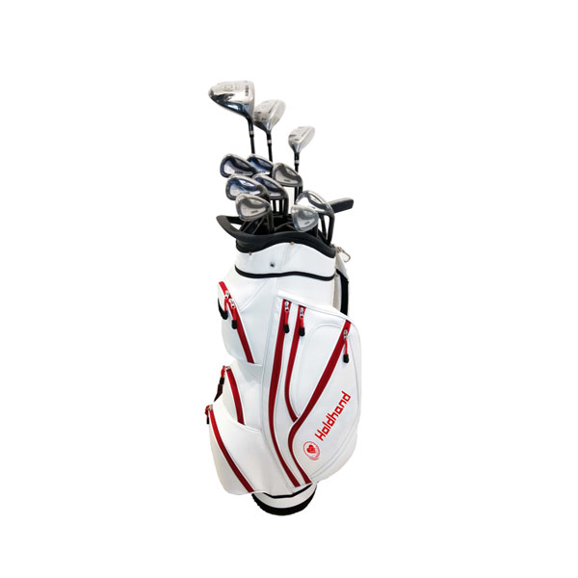
More information please click: www.tt-golf.com

